**EMR - LIMS Module Setup Guide**

This document outlines the necessary steps for installation of EMR - LIMS module. The NMRS module is a prerequisite for the installation of the EMR - LIMS module. it is expected to have the all NMRS module installed before the EMR - LIMS module can be installed.

**Requirements**

* NMRS 2.0 modules

**Step 1. Modify database (DO THIS BEFORE deploying the omod and STARTING NMRS Instance)**

*On your database client, run the following script*

ALTER DATABASE `YOUR_DBNAME`

DEFAULT CHARACTER SET utf8

DEFAULT COLLATE utf8_general_ci;

**Step 2. Deploy EMR - LIMS Modules**

* Navigate to the path where the NMRS modules is located as seen in the screenshot below

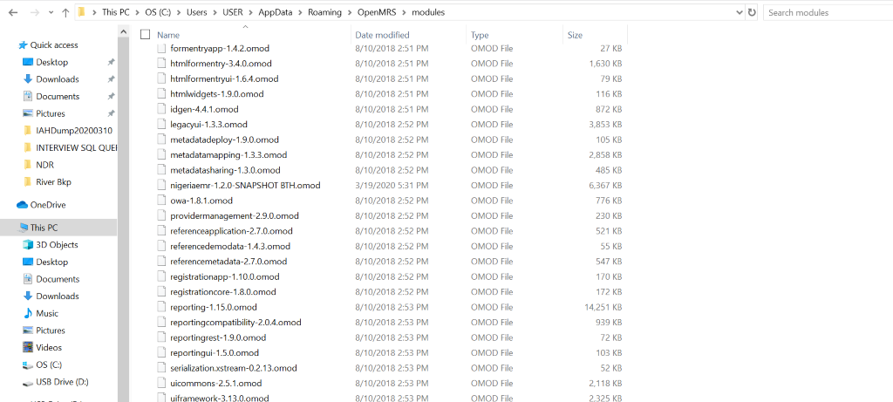

**Setup 3. Launch Nigeriamrs Module**

* Startup apache Tomcat service
* Launch Nigeriamrs from the browser via localhost:8080/Openmrs
* Provide login details